

Popular Youtube Videos Analysis

Jiexin Lan, Xinyue Dong, Qihui Sun

New York University

Professor Marc Bacchus

MASY1-GC3500

December 10, 2019

**Overview**

Company name: Youtube

Company background: YouTube is an American video-sharing website, which is located in San Bruno, California. YouTube allows users to upload, view, rate, share, add to playlists, report, comment on videos, and subscribe to other users. It offers a wide variety of user-generated and corporate media videos. YouTube now operates as one of Google's subsidiaries.

**Goals**

1. To analyze and build relational database with structured and reliable data.
2. Generate report about elements provided in the database to assist Youtube to expand market share, boost up customer volume, improve customers’ viewing experience and enhance competitiveness with other video-sharing websites.

**Deliverables**

1. Introduction of data model and data preparation
2. Report about popular property in Category
3. Report about popular condition in Channel and Video

**Data Model**

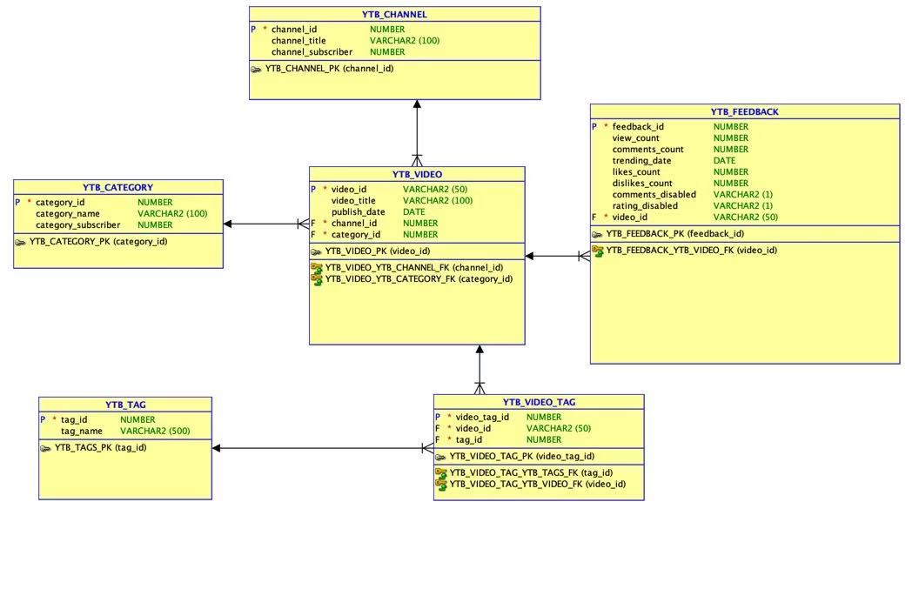

**Data Preparation**

1. Included the whole dataset by dataset provider Mitchell J..
2. in order to have clear and better analysis, reduced data size to 100.
3. Added new related data: channel name, channel followers and category name
4. Formatted the data to the form needed.

**Analysis Part**

**Category Part**

1. Number of trending video in each category

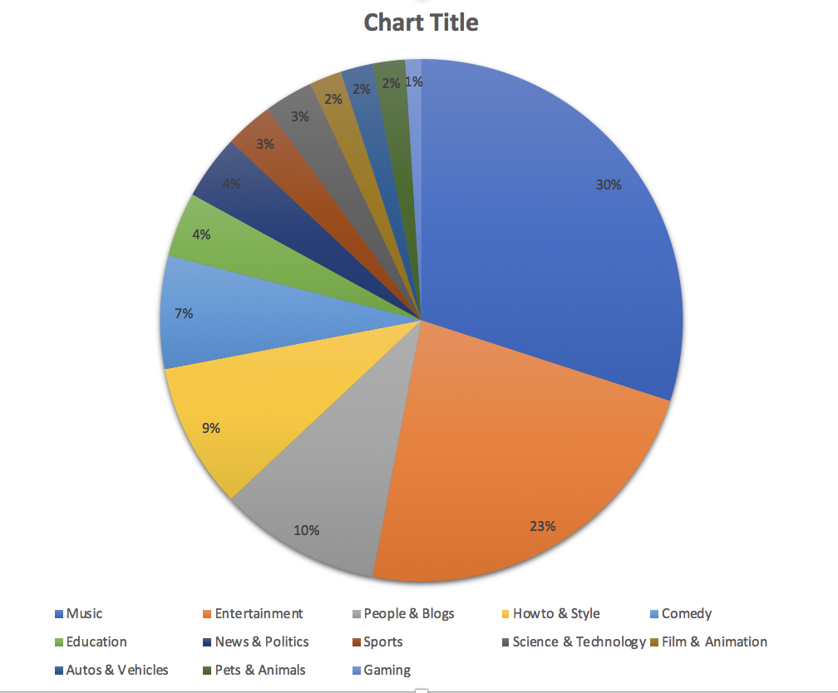

1. Total views in each category

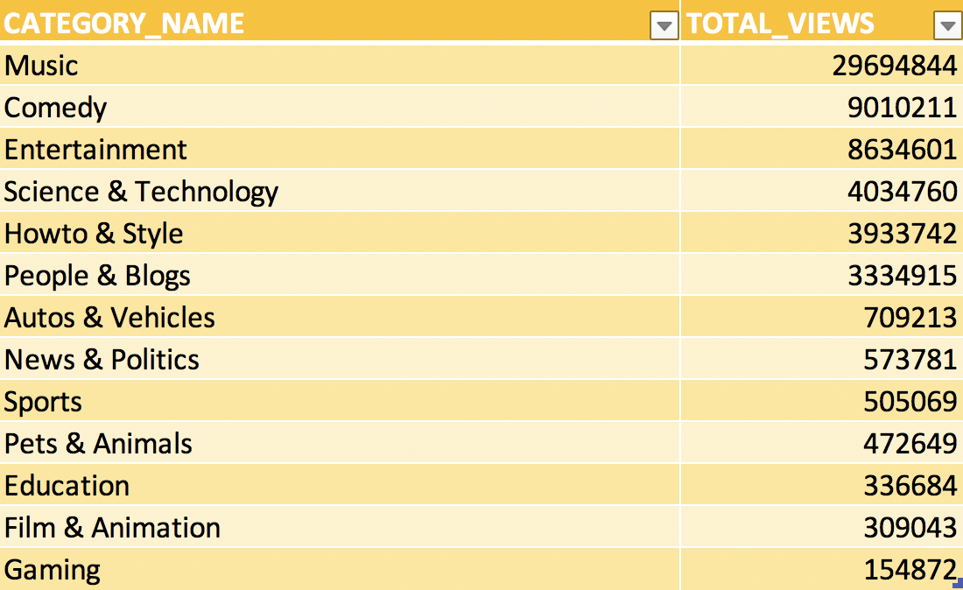

1. Average view in each category

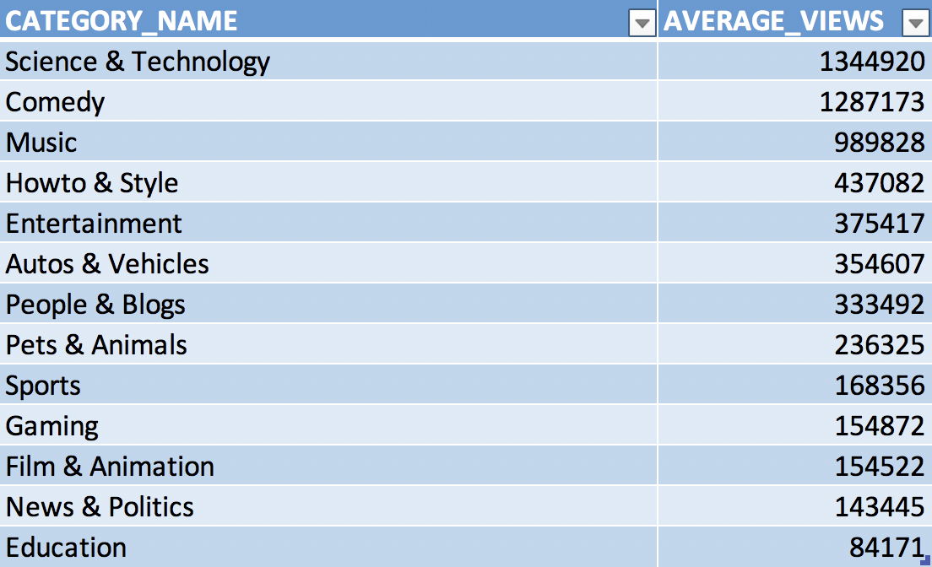

1. Category subscriber and sum of channel subscriber for each category

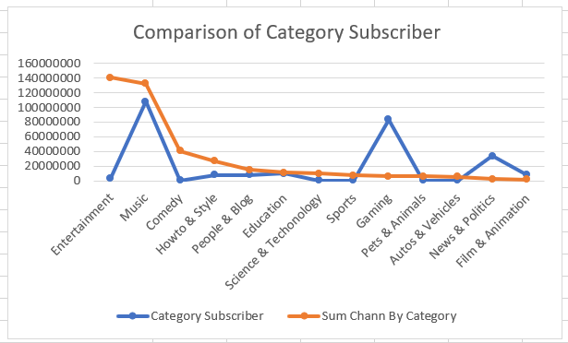

1. Channel subscriber frequency in different range for each category

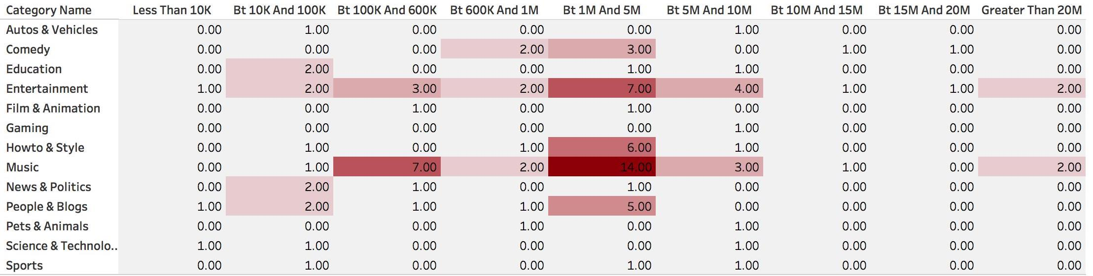

**Channel and Video Part**

1. Most popular tags: Tags appeared over 3 times

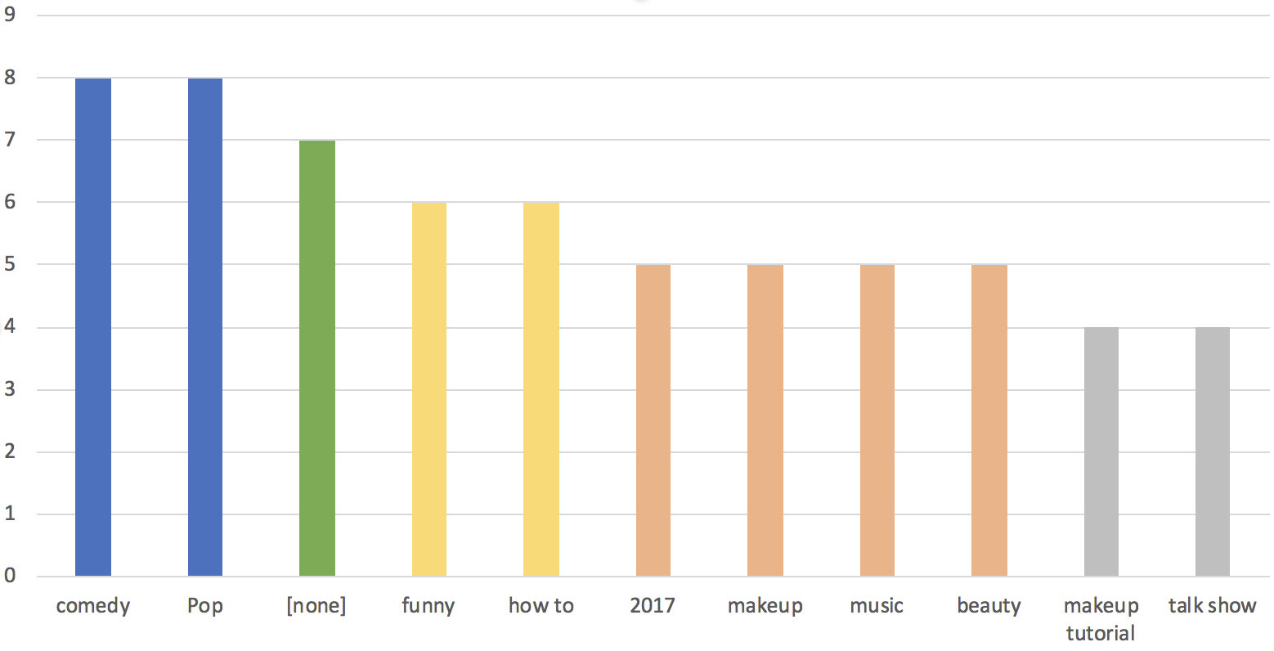

1. Trending length frequency

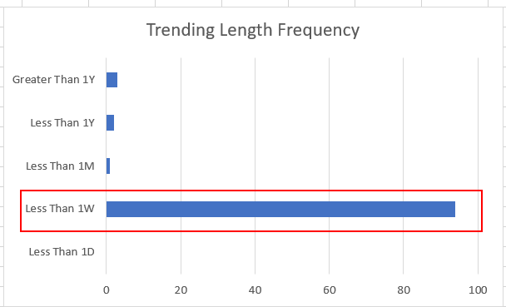

1. Top 10 most video’s likes ranking

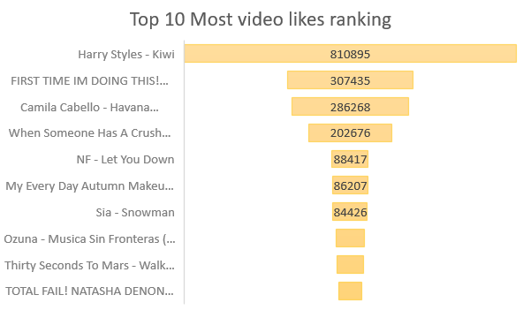

1. Top 10 least video’s likes ranking

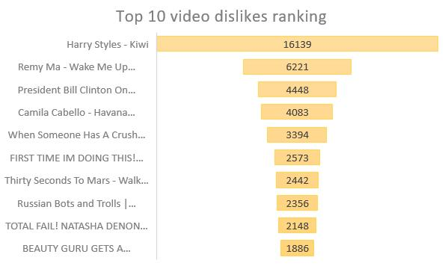

1. Top 10 least video likes ranking

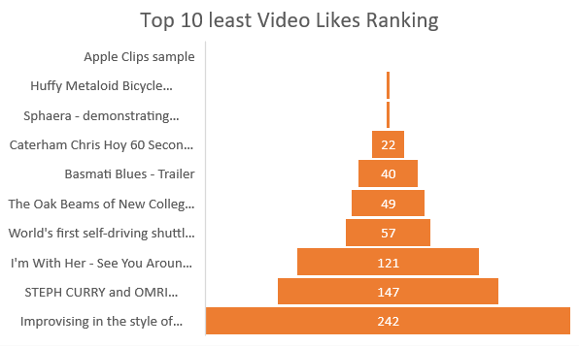

1. Top 10 least video dislikes ranking

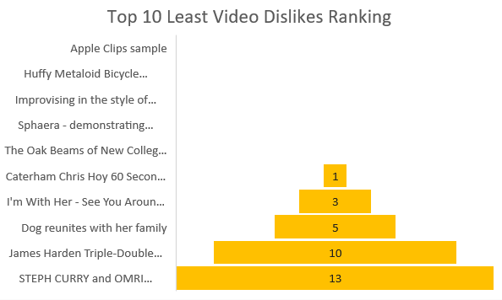

1. Top 10 popular video

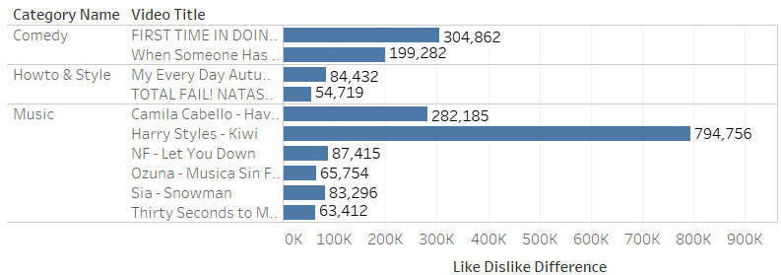

1. Top 10 unpopular video

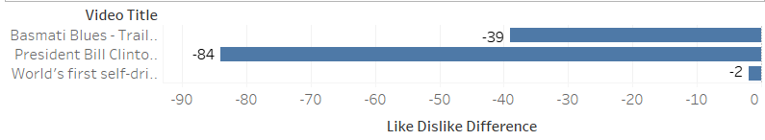

1. Top 10 most video views ranking

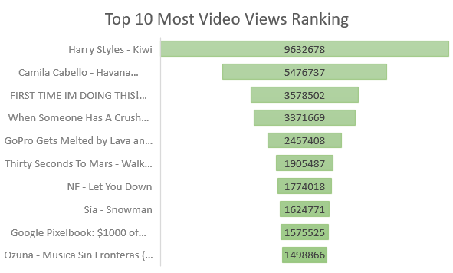

1. Top 10 least video views ranking

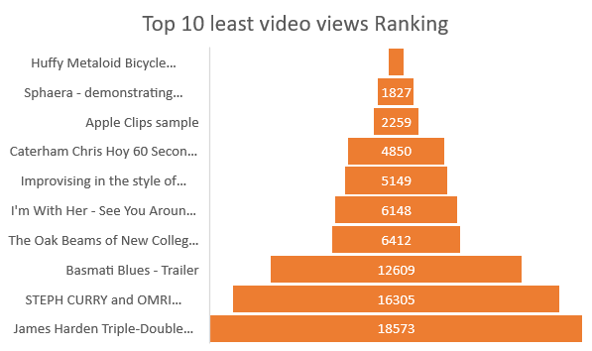

1. Top 10 video within Category

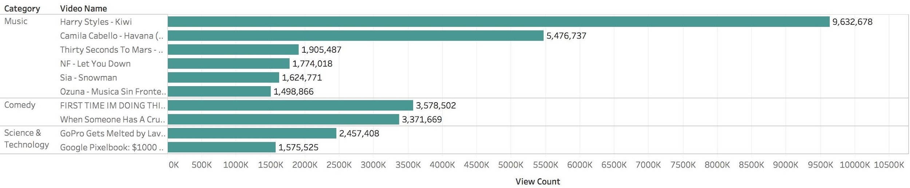

1. Top 10 most video comments ranking

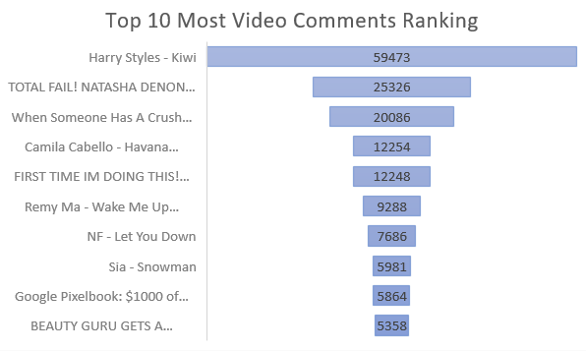

1. Top 10 least video comments ranking

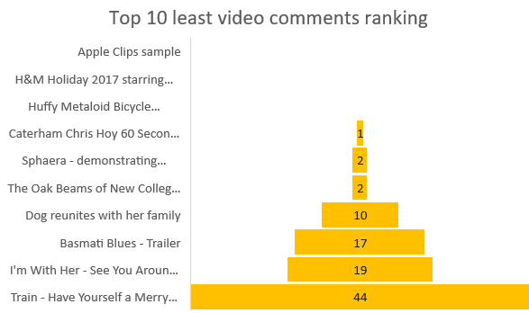

Appendix -- SQL

1. Most trending video in category

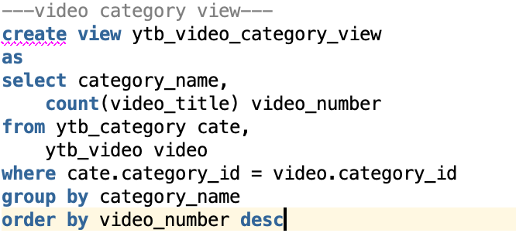

1. Highest view

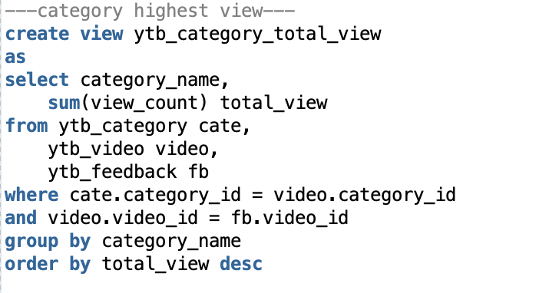

1. Average view

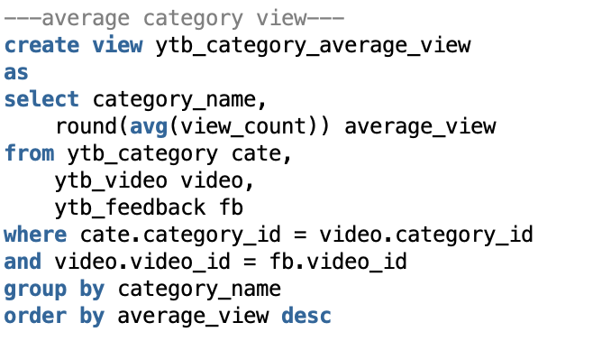

1. Category & Channel subscriber

1. Trending days A screenshot of a cell phone

   Description automatically generated
2. Channel Subscriber in different range

1. Popular tag

1. Top 10 most video likes ranking

1. Top 10 least video likes ranking

1. Top 10 most video dislikes ranking

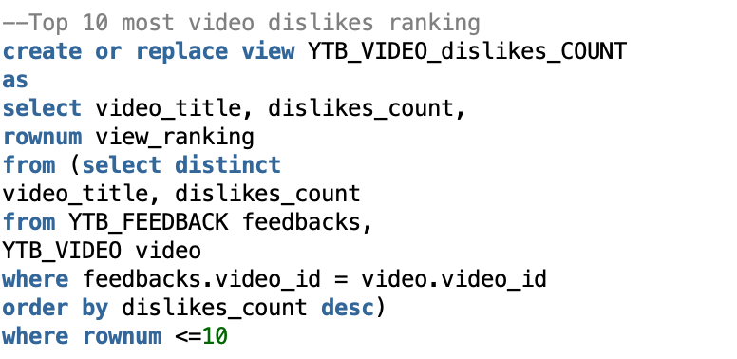

1. Top 10 least video dislikes ranking

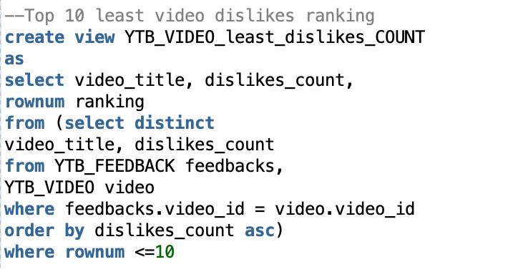

1. Top 10 popular video; unpopular video

1. Top 10 most video views ranking

1. Top 10 least video views ranking

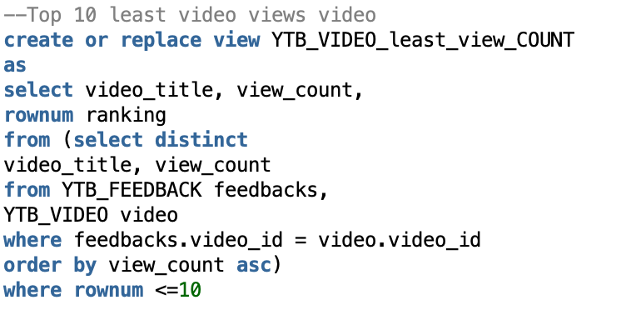

1. Top 10 video view within category

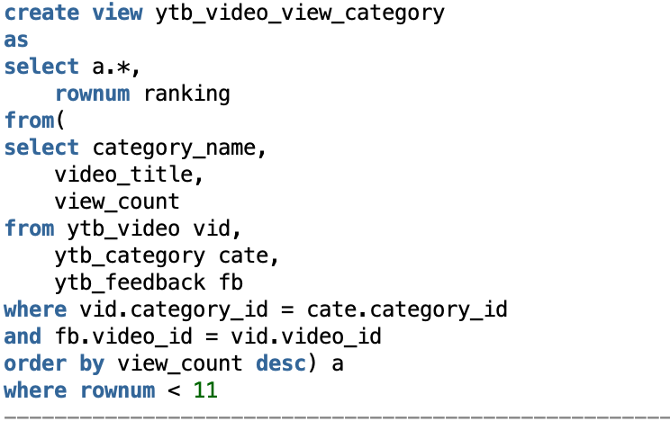

1. Top 10 most video comments ranking

1. Top 10 least video comments ranking

